Hong Kong PhD Fellowship Scheme – Students’ sharing

For details, please visit the following URL :

http://www.ece.ust.hk/public/admissions/student_sharing.html#PhD_Fellowship_Scheme


Wei CHEN
Admitted to PhD(ECE) in 2010
"I obtained my Bachelor's degree from Peking University in 2008. After fulfilling my MPhil study at the ECE of HKUST in 2010, I was determined to continue to pursue my PhD degree at this university. The encouraging environment here for creativity, critical thinking and global outlook has enhanced my development greatly. I strongly believe that it will lay a solid foundation for my future career."

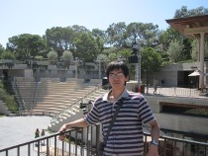
Wei DAI
Admitted to PhD(ECE) in 2010
"My name is Dai Wei from Zhejiang University. Now I am a PhD student and my research interest is in video coding. It was really a coincidence to learn about the HKPFS in HK. Once I knew about such a fellowship, I made up my mind to apply for this fellowship within a second because of the reasons below:
First of all, this fellowship really provides a lot of money such that I can focus on my research without worrying about other things. Second, Hong Kong is really a wonderful place for me to study especially in HKUST which is really an excellent school. Third, I think Hong Kong is a well known international city where I can broaden my views and experience more compared to other places.
It is almost one year since I came to HK. I think HKPFS has really helped me a lot in pursuing mu studies in this year. Moreover, this award enabled me to make a lot of other friends in the university which is really exciting."

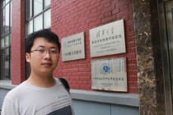
Yunyou LU
Admitted to PhD(ECE) in 2010
“I came to the ECE Department, HKUST to study as a PhD student in the semiconductor device technology after my undergraduate study in mechanical engineering. Engaging with people of different backgrounds and areas who may have different manners and philosophy in conducting research is of benefit to all of us. Undoubtedly the ECE Department of HKUST is one of the world's most active and advanced centers for microelectronics research. HKUST is a compactly designed young university which is rushing towards new miracles and the Fellowship Scheme is a great support for research and international activities.”

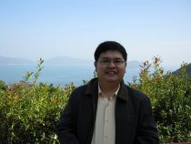
Ying-Khai TEH
Admitted to PhD(ECE) in 2010
"I am a PhD candidate in the Integrated Power Electronics Laboratory of the ECE Department, under the supervision of Prof Philip Mok. I chose to further study in Hong Kong as it is the world city of a growing Asia, where many great minds come to share their ideas. I specifically chose HKUST as it offers one of the finest IC design research programs in the world, proven by its consistent publication records in top IEEE journals and conferences. I am grateful for the generous award of HKPFS as it solves my financial worries to study in this expensive city."

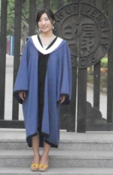
Shu YANG
Admitted to PhD(ECE) in 2010
"I am Shu YANG, a PhD candidate in the ECE Department, under the supervision of Prof. Kevin J. CHEN. I have been honored with HKPF in 2010-2011. I have been making great progress in the research field and am enjoying life here. I must emphasize that studying in the HKUST has always been a dream of mine. With extraordinary professors, advanced facilities, excellent peers, wonderful academic atmosphere, I think I can absolutely tap into my potential and explore the unknown world. HKPF has greatly helped me in both life and research, making me focus on my research field and providing more opportunities to communicate with professors and peers."

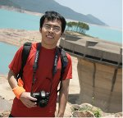
Lining ZHANG
Admitted to PhD(ECE) in 2010
“I received the HKPF and joined the ECE department in HKUST in September 2010. HKUST provides a dynamic research environment to faculties and students. If you come to ECE, you will find that there are a lot of smart, energetic and responsible faculties around you. From them you will not only learn how to do research but also how to prepare yourself for future development.
The school organizes tea gathering for HKPF awardees every semester and provides us with the chance to make friends from different areas. I have benefited a lot from talking to them.
I am Lining Zhang and strongly recommend you to come to ECE@HKUST.”

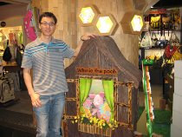
Weibin ZHANG
Admitted to PhD(ECE) in 2010
"Hi, I am ZHANG Weibin, a second year PhD student in the ECE department. I come from Guangdong province, China. I spent nearly 10 years in Shanghai, pursuing my bachelor degree and working. After working for a company for about 2 years, I found that it was very boring. Besides, I dreamed about going back somewhere near my hometown so that I could take care of my parents much better. One day, one of my good friends told me that there was a prestigious award –HKPF—in Hong Kong. I decided to try it. One of the key things was to choose which school to go to. Apparently, excellent faculty is very important. However, I also liked to study somewhere near the seaside. Thus I chose HKUST. Fortunately, I was one of the 135 lucky guys that were in the first batch of awardees of the HKPF. After two years of study in HKUST, I found that life here is somewhat different from what I thought before. Because of the high expectation of the department as well as my supervisor, I feel much pressure here. Maybe you should check another meaning for HKUST before coming here. If you want to challenge yourself and do something really good, come here. Hope to meet you here and be your friend!"

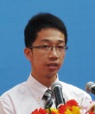
Liang LI
Admitted to PhD(ECE) in 2011
"I’m Li Liang, a mainland awardee of HKPFS from UESTC. My major is IC design and about a year ago, I heard about HKPFS. At that time, like many of my classmates who were applying to graduate schools outside mainland China, I was wandering around different university websites. HKUST was one of my target universities because of its good research reputation in engineering in Asia. In addition, Hong Kong’s advantage of exposing myself to international atmosphere and standards without being too far away from home was very attractive to me. When I was doing online application, I saw the HKPFS banner on the webpage. Through reading the introduction and asking my friend who was already a postgraduate student in HKUST, I decided to apply for it. Frankly speaking, I lacked confidence at that time because HKPFS only selects the best students with potentials of future achievement from all over the world and no more than 200 out of thousands of applicants have the chance to be awarded. Although I was not confident, I decided on, “if it doesn’t take much time, why not give it a try”. So I submitted my application. Months later, it turned out to be a success. I can still remember the exciting feeling when I got the email stating that I was awarded the HKPF.
Looking back now, I think good undergraduate academic performance and my undergraduate research experience contributed the most to my successful application and this successful application also increased my confidence somehow. Thanks to the HKPFS and the ECE Department, I am now very happy as a member of the ECE big family and working hard to realize my dream step by step at being an excellent researcher in IC design.
You won’t know how far you can go unless you step out and try. HKPFS will help you and won’t let you down!"

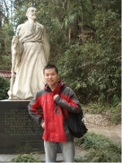
Fan YANG
Admitted to PhD(ECE) in 2011
"I’m YANG Fan. I graduated from Zhejiang University, China, with a Bachelor’s Degree and entered ECE, HKUST in fall, 2011. Besides outstanding academic performance and research experience, I also won some national and international awards, which became solid foundations for me to apply for the HKPF. I thought HKUST was a place where I believed I could better realize my dream: to maintain a green and efficient life for society, as it has the best professors, state-of-the-art facilities and top students with similar dreams from all over the world. I’m new in HKUST, but I felt the beauty of it at first sight and began to know more about its advantages in all aspects. Within a reasonable timeframe, on this beautiful campus, I can focus and plan my life in accordance with my research in IC Design."

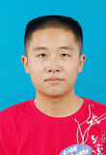
Shibo CHEN
Admitted to PhD(ECE) in 2011
"Hello, my name is Chen Shibo. I'm from the University of Science and Technology of China.
After living in HKUST for a period of time, I now feel it's a really great place. Although it's young, it has been one of the top-class universities in the world. As for the ECE Department, with such an outstanding group of faculty and so many talented students around, I believe everyone here will have a prominent career in the future.
Actually it's been a long time since I first dreamed about studying in HK. Thanks to the HKPFS, my dream has finally come true. With this fellowship, I won't worry about the cost of living any more so I can focus on my research and try my best to make some achievements here.
Anyway, welcome to HKUST! Welcome to ECE!"

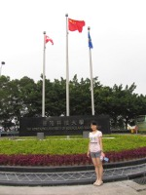
Lu YANG
Admitted to PhD(ECE) in 2011
"Just graduated from Xi’an Jiaotong University, I’m really very lucky to have the opportunity to continue my study in HKUST, a university full of energy and miracles. As a young student with ambitions, I hope to devote all my passions to my study, my research area and my life.
The technology of wireless communication can bring much convenience to people’s daily life, and has been widely used in communication, transportation, news media and other aspects. Wireless communication and networking is one of the most renowned areas of excellence in HKUST. I believe my research work here will enable me to make contribution to this discipline as well as humankind.
HKPFS gives me a very strong support in economy so that I can concentrate my efforts on my research. What’s more, in the gathering of HKPF awardees, I can also make friends with the excellent people from all over the world.
In HKUST, there are many excellent supervisors and brilliant, hard-working students. I trust I’ll gain a lot working together with the people who cherish the same ideas and follow the same path. I wish we can together contribute towards the next miracle of the university."

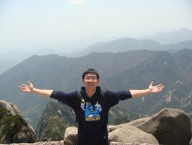
Cheng LI
Admitted to PhD(ECE) in 2011
"My name is LI Cheng and I’m from Shandong province. I got my Bachelor’s Degree in Engineering at Zhejiang University. Now my PhD program in the ECE Department at HKUST is setting sail. The field of automation and robotics really catches my interest with its cool technologies and wonderful future, so I choose robotics as my specialty, wishing that people will live more conveniently and have colorful lives with the help of robots.
In my opinion, HKPFS is more than a kind of scholarship. I view it as an honor of the best students with potential to get higher achievement in the world. As a student who aims high, surely I wanted to challenge myself and applied for HKPFS.
Hong Kong is a magic place. It keeps up with the pace of the latest improvements all over the world, while the connection between Hong Kong and mainland China can be so close. HKUST has one of the best academic environments which will really promote the research of any professors and postgraduate students. Moreover, HKUST ranks No. 1 in all Asian universities. So I choose to pursue my PhD degree here."

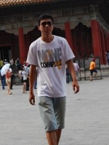
Duo HAN
Admitted to PhD(ECE) in 2011
"Hong Kong is an amazing city that every prospective graduate student might look forward to. The universities in Hong Kong stand out for their ample resources and international atmosphere. HKUST is one of the top universities in Asia and especially its Engineering School holds a fantastic reputation throughout the world. There are many globally renowned scholars and experts, well-developed research network linking Mainland China, Europe and the United States. HKPFS offers a remarkable fund covering all the expense of living and learning in HKUST and many opportunities of meeting other awarded candidates who are elites in their respective research areas. During my studies, I can attend conferences supported by the travel allowance in the fellowship. This award renders me to concentrate on my research without considering financial issues and pushes me towards being an outstanding scholar in the future."

