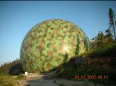
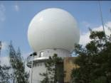
CSZH specializes in R&D, production, assembly and after-sales service for high performance radome.

CSZH produces radome ranging from ￠3 meters to ￠40 meters, and the frequency includes: P band, L band, S band, C band, X band, Ku band, Ka band and broadband. ￠8.6m、￠11.8m、￠17m and ￠25m radome have passed overall electrical performance tests.
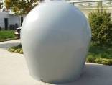
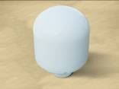
CSZH radome has been successfully installed in the field of meteorological, civil aviation and national defense. CSZH large ground-based radome has been exported to America, Germany, South Korea, Australia, Pakistan, Venezuela, etc. In addition, we also design and produce air-bone, ship-bone, vehicle-bone radome and high-precision carbon fiber antenna reflector.


Depending on its fine and reliable performance, CSZH radome has been equipped with abroad advanced radar in meteorological and civil aviation application. Such as: America RAYTHEON, Canada INTELCAN, Sweden C2SAT, Spain INDRA and France THALES.
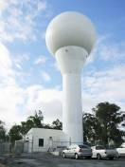
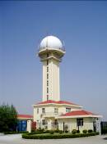
Factory Add: No.185 Laoguo Rd, Nanhui District, Shanghai
No. | Diameter (m) | Operating Frequency | Structure Form | Electrical  Performance | Other Specifications
1 | Φ4 | P band  L band  S band  C band  X band  Ku band  Ka band  Broadband  1~ 40GHZ | Random  Polygonal  Foam-sandwich | Transmission Loss:  Overall:≤0.2~0.3dB  Individual Panel:  ≤0.1~0.2 dB  Seam : ≤0.3~0.5 dB  Side Lobe Level:  Overall:  +1 dB(-27dB)  +2 dB(-35dB)  Bore Sight Error:  Overall:≤ 0.02º  VSWR:≤ 5% | Wind Load:  ≤67m/s no damage  Ambient Temperature:  -50℃~+70℃  Relative Humidity:  0~100%  Three Proofings:  Moisture Proofing, Salt Spray Proofing and Fungus Proofing)  Life Span: ≥20 years  Color: white, camouflage etc.
2 | Φ4.5
3 | Φ5.9
4 | Φ6.5
5 | Φ7.2
6 | Φ8.6
7 | Φ9.14
8 | Φ10.7
9 | Φ11.8
10 | Φ15
11 | Φ17
12 | Φ20
13 | Φ23
14 | Φ25
15 | Φ40
16 | ≤3 |  | Integral Radome
T: (86)21-58050890 F: (86)21-58051449
Headquarter Add: 19A1, Building 1, No.345 South Ruijin Rd, Shanghai
T: (86)21-53014006 F: (86)21-53014007
E-mail: sales@zhihefrp.com

